SKN COLLEGE DATABASE MANAGEMENT

**1 ) Introduction**

College Data Management System gives a straightforward interface to support of understudy data, staff information,attendance,fee record. It very well may be utilized by instructive establishments or schools to keep up the records of understudies without any problem. KK

**2) E-R Diagram :**

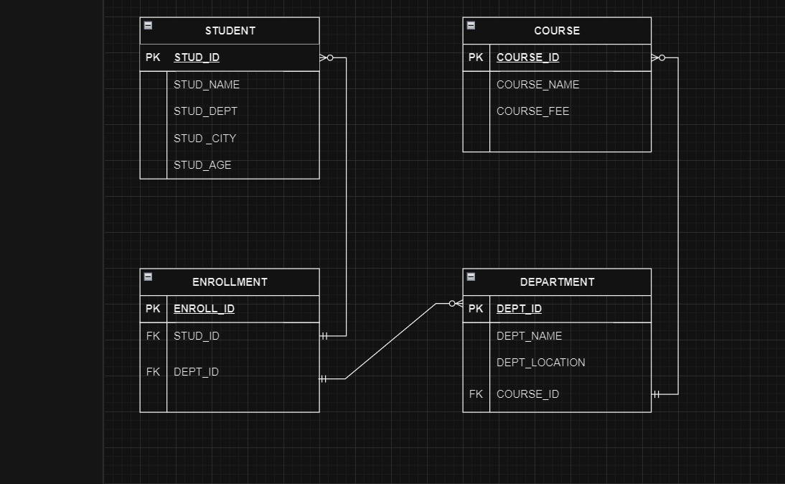

**3) Structure of Tables :**

**3) Student-**

This table stores information about each student such as id,name,department,city age.

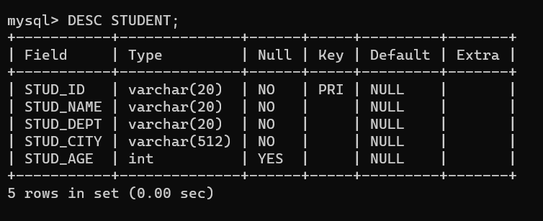

**Course-**

This table contain all information about each couse such as id,name,fees.

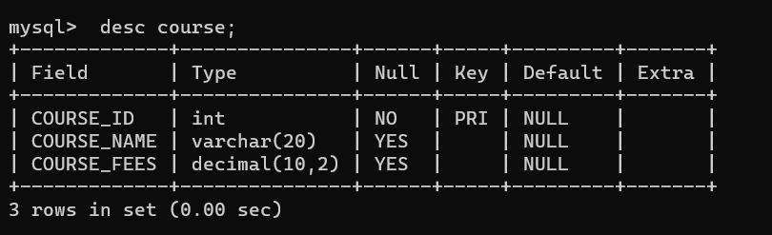

**Department-**

This table contain all information about each department such as id,name,location

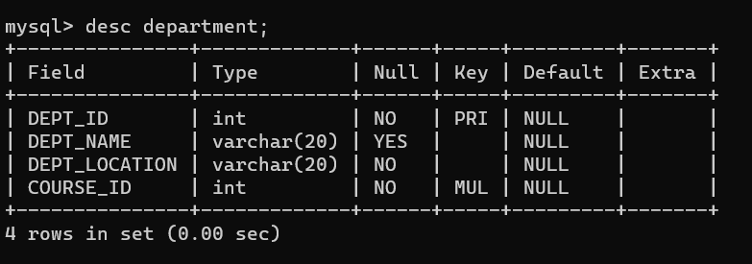.

**Enrollment-**

This table contain all information about each enrollment such as id

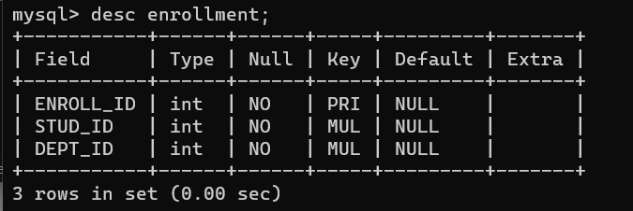

**4) Contents of Tables**

**Student-**

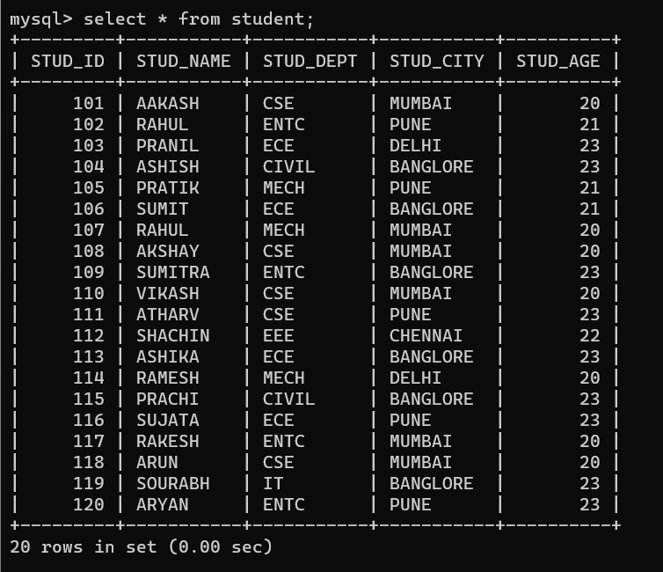

**Course –**

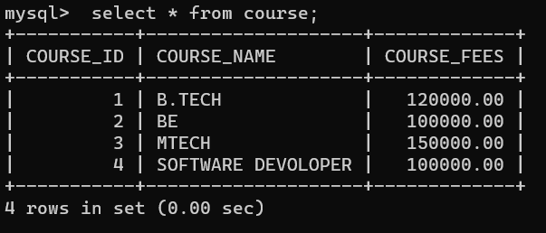

**Department –**

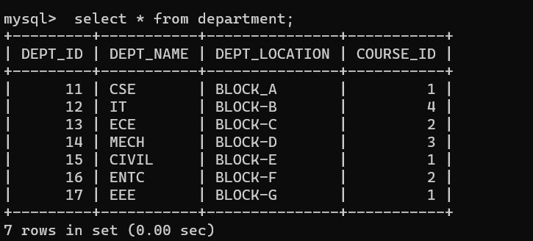

**Enrollment –**

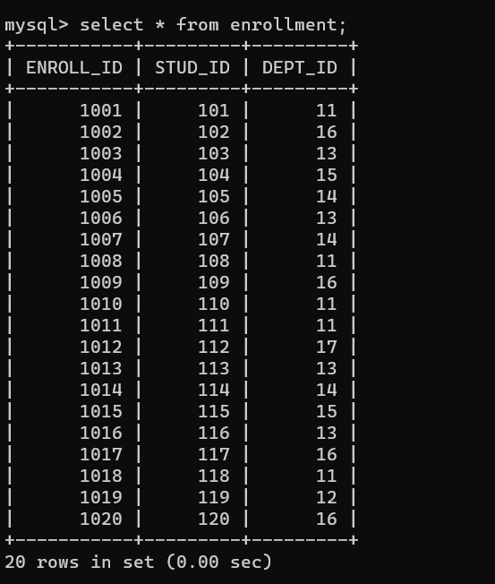

1. **Sub Queries :**

**Question 1 -**

The names of students who are enrolled in courses with ENROLL_ID equal to 1001, 1005, and 1010,

**Query -**

SELECT STUD_NAME FROM STUDENT WHERE STUD_ID IN (SELECT STUD_ID FROM ENROLLMENT WHERE ENROLL_ID IN (1001, 1005, 1010));

**Output -**

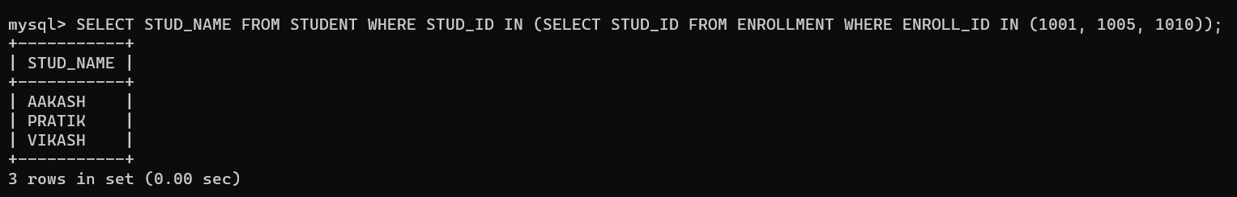

**Question 2-**

The names of students who are enrolled in departments with DEPT_ID equal to 13, 14, and 15.

**Query -**

SELECT STUD_NAME FROM STUDENT WHERE STUD_ID IN (SELECT STUD_ID FROM ENROLLMENT WHERE DEPT_ID IN (13, 14, 15));

**Output -**

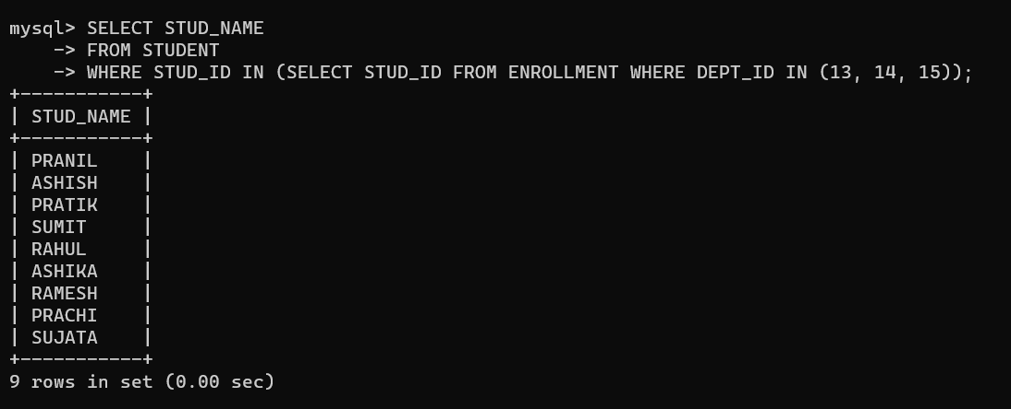

**Question 3-**

Find the department name for the course with the highest course fees.

**Query -**

SELECT DEPT_NAME FROM DEPARTMENT WHERE COURSE_ID = (SELECT COURSE_ID FROM COURSE ORDER BY COURSE_FEES DESC LIMIT 1);

**Output -**

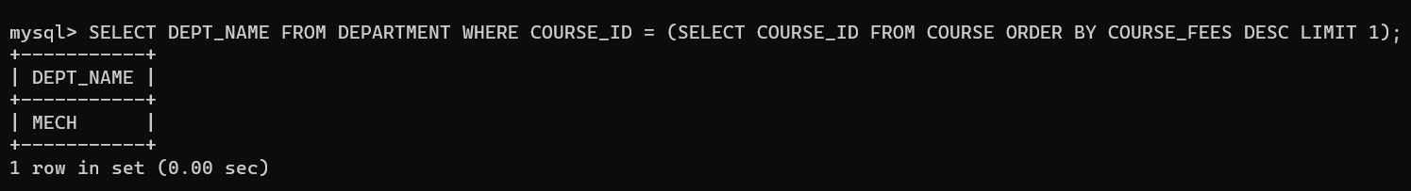

**5)Joins :**

**Question**  **1**

Display list of students and their enrolled departments?

use an INNER JOIN

**Query -**

SELECT STUDENT.STUD_NAME, ENROLLMENT.DEPT_ID FROM STUDENT INNER JOIN ENROLLMENT ON STUDENT.STUD_ID = ENROLLMENT.STUD_ID;

**Output -**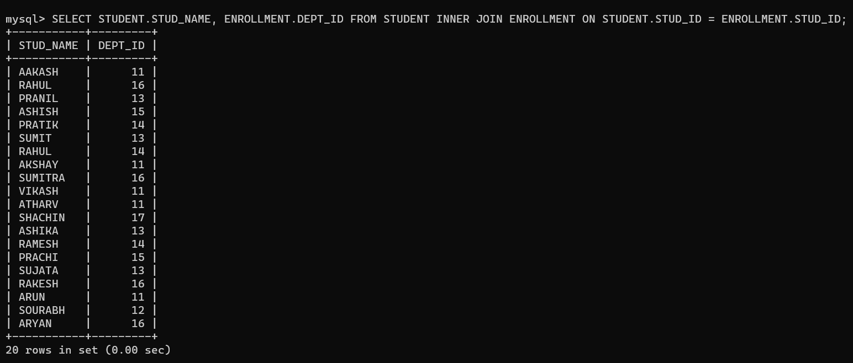

**Question**  **2**

Display list of students along with their department and city?

**Query -**

SELECT STUDENT.STUD_NAME, ENROLLMENT.DEPT_ID, STUDENT.STUD_CITY FROM STUDENT INNER JOIN ENROLLMENT ON STUDENT.STUD_ID = ENROLLMENT.STUD_ID;

**Output -**

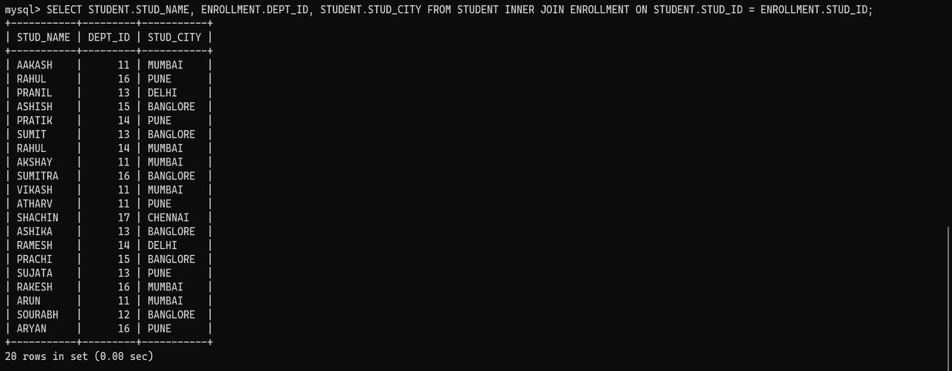

**Question**  **3**

Select all rows from course table using left join and the match with the right table depaertment

**Query -**

SELECT * FROM COURSE AS C LEFT JOIN DEPARTMENT AS D ON C.COURSE_ID = D.COURSE_ID

**Output -**

